
United International University (UIU)
Mid Term Examination
IPE 401/IPE3401: Industrial Management/Industrial & Operational Management

Spring Trimester: 2025
Total time: 1 hour 30 mins Date: 12/4/2025 Total marks: 30
There are 5 questions. You must answer any 4 questions
1 | (a) | Mr. Suman invested some money at 15.5% interest rate compounded weekly for 40 years, and Mr. Sunny invested some money at 26% interest rate compounded quarterly for 30 years to reach 8 million. Whose investment was higher? And how many years it took for Sunny to reach 5 million? Show with necessary calculations. | [4] | [CO2]
 | (b) | A public project is being assessed for feasibility based on projected benefits and costs over a 5-year period. At year 0, the project requires an initial investment of $50, with no immediate benefits. In year 1, benefits are projected at $30, while costs are $10. Year 2 forecasts $40 in benefits with $10 in costs, followed by year 3 with benefits of $50 and costs of $15. By year 4, benefits are expected to be $30, with associated costs of $20. In the final year, both benefits and costs are estimated at $20. Assuming an interest rate of 8% compounded monthly, compute the Benefit-Cost Ratio (B/C) to evaluate whether the project should be accepted or rejected. | [3.5] | [CO1]
2 | (a) | 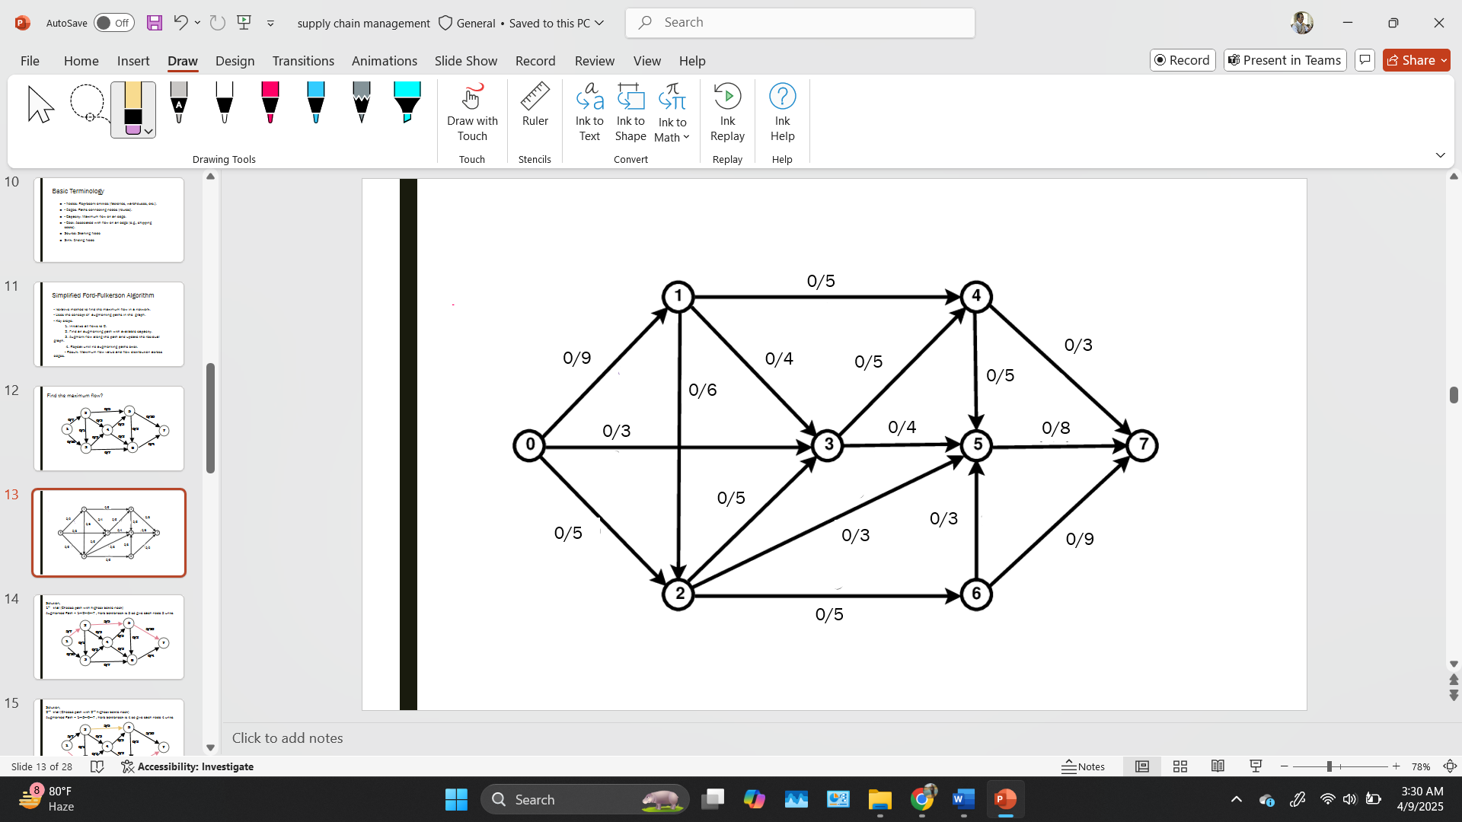  Find the maximum flow? | [3.5] | [CO2]
 | (b) | Two projects are given  Project “A”  Year 0 1 2 3 4 5  Cash Flow -30200 5520 8500 12300 16300 20000  Project “B”  Year 0 1 2 3 4 5  Cash Flow -25,200 8,900 10,000 6,200 6,600 17,500  Now select the project using the Discounted payback period method and consider the rate = 23% compounded weekly. Which project should you select? | [4] | [CO1]
3 | (a) | What do you mean by Economic order quantity? Explain with the necessary diagrams. | [3] | [CO2]
 | (b) | Year 0 1 2 3 4 5  Project A -10,0000 30,000 40000 50000 20000 15000  Project B -200,000 65,000 58,000 55,000 37,000 40,000  Calculate the IRR, starting from 10%, using the trial-and-error method. If the required rate of return is 12%, should the company accept the projects? (You must show the necessary calculations). | [4.5] | [CO1]
4 | (a) | A cheese factory produces specialty cheese wheels and operates 300 days a year. The weekly demand for the cheese wheels is 1,200 units, and the factory produces them at a rate of 600 units per day. Every time a production run is set up, it incurs a cost of $400. The annual holding cost per unit is $1.50. Calculate the optimal production batch size, the total annual setup cost, and the total annual holding cost. | [3] | [CO2]
 | (b) | A steel factory is open for 250 days a year. The demand for refractory material in the factory is 80 bags per day. Whenever an order is placed, it costs $60, and the holding cost per unit per year is 30%. The quantity schedule chart is given below. Determine Optimal order quantity and Total cost associated with it.  Discount Number Discount quantity Discount % Discount price$  1 0 to 400 No discount 17  2 401 to 650 10% ?  3 651 and over 14% ? | [4.5] | [CO2]
5 | (a) | Task Predecessors Duration  A -- 3  B -- 4  C A 5  D B 3  E A, B 6  F C,D 4  G E 5  H F,G 3  Find the Critical Path. | [5] | [CO2]
 | (b) | Year 1 2 3 4 5  Revenue 0 2500 4000 5500 1000  Cost 6500 3500 3000 1500 750  Find the future value 13% monthly rate and state that will you invest in the project or not?  CO1-Apply Engineering economics and simple mathematics for Solving project selection problems for choosing the best possible project.  CO2- Analyze various industrial problems by using operation management, technique, operation research technique and cost accounting techniques and solve it. | [2.5] | [CO1]

